---

AP LAB - 2

NAME: SHEEFA NAAZ

ROLL NO.: 2128085

SECTION: CSSE 2

DATE: 03-08-2023

- Initialize some variables on r workspace with different types of values then analyze and display what are variables you have created then delete the single variable as well as all the created variables.

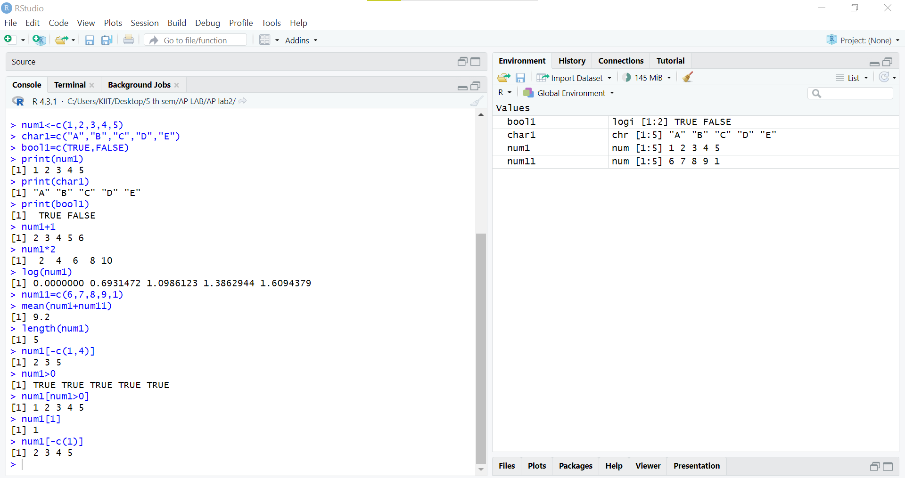
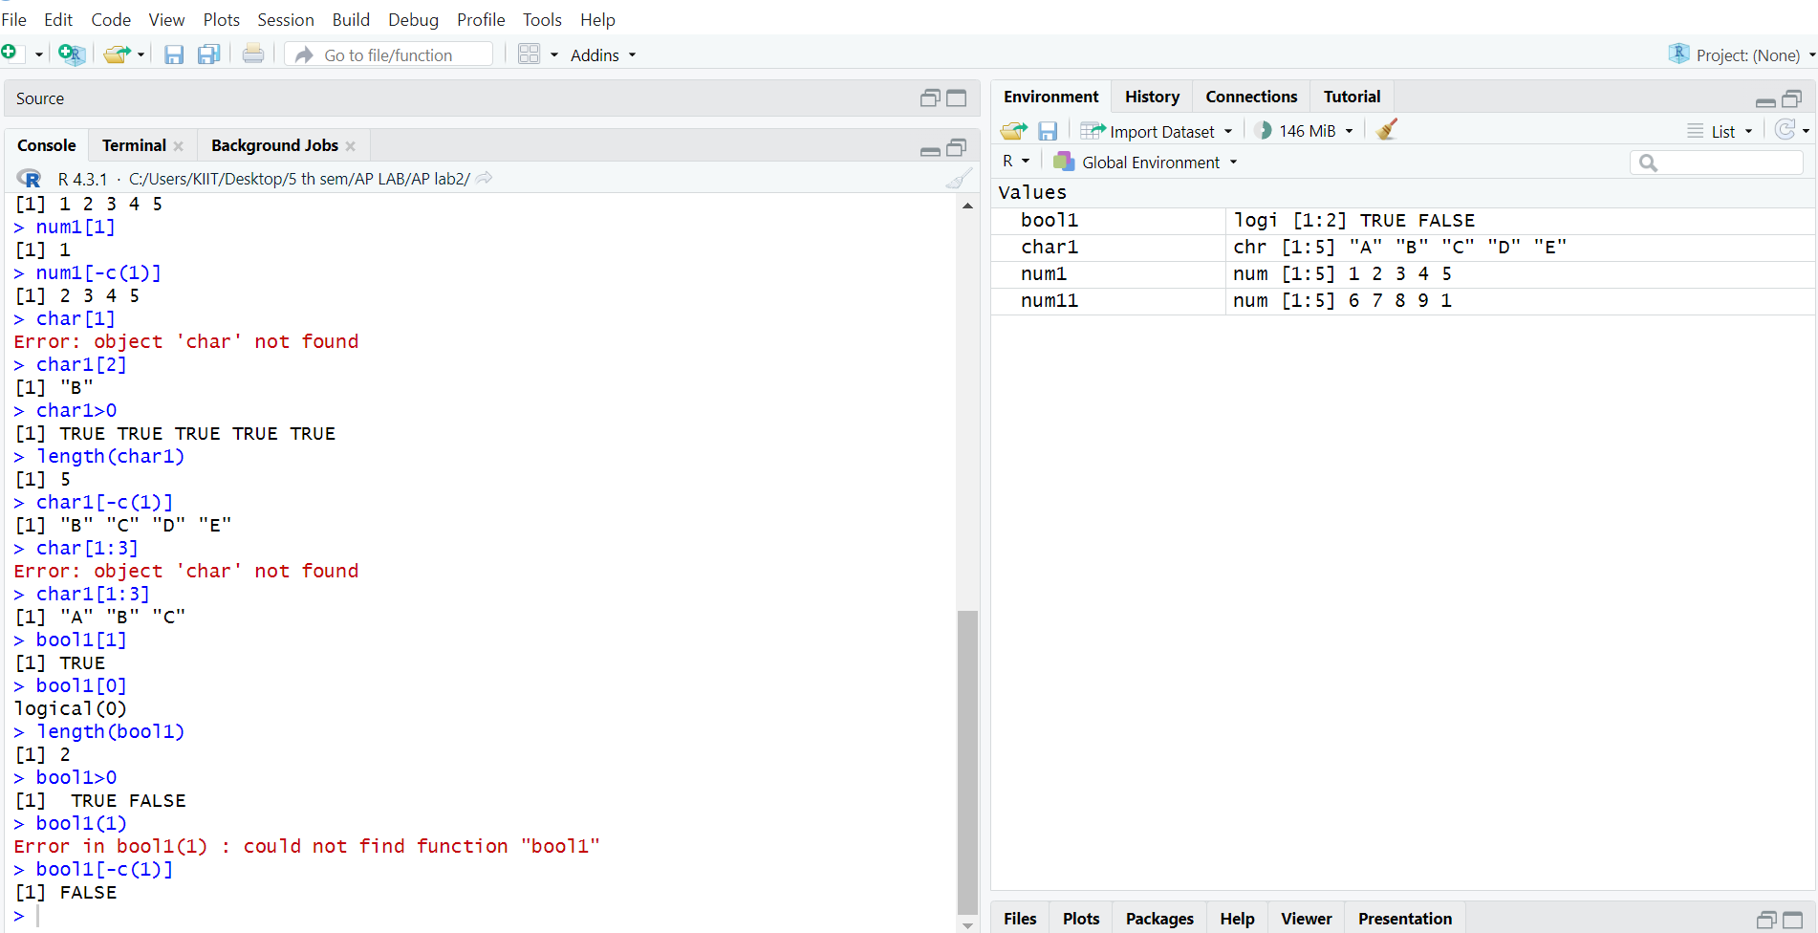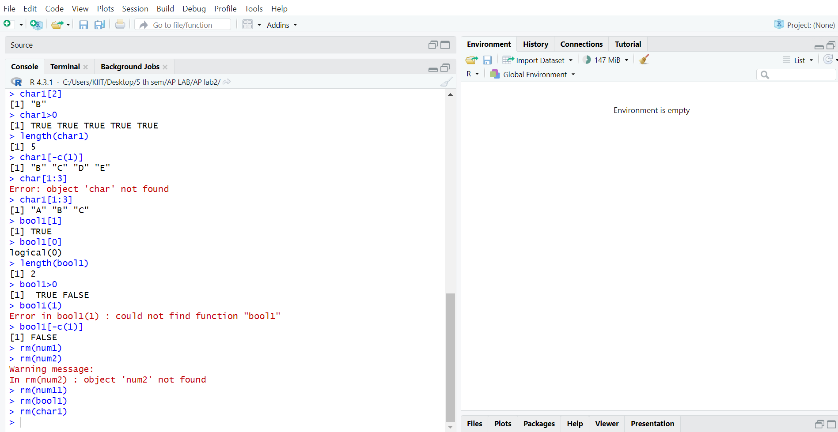

- Initialize some variables with different types of values now analyze what is the type of those variables.

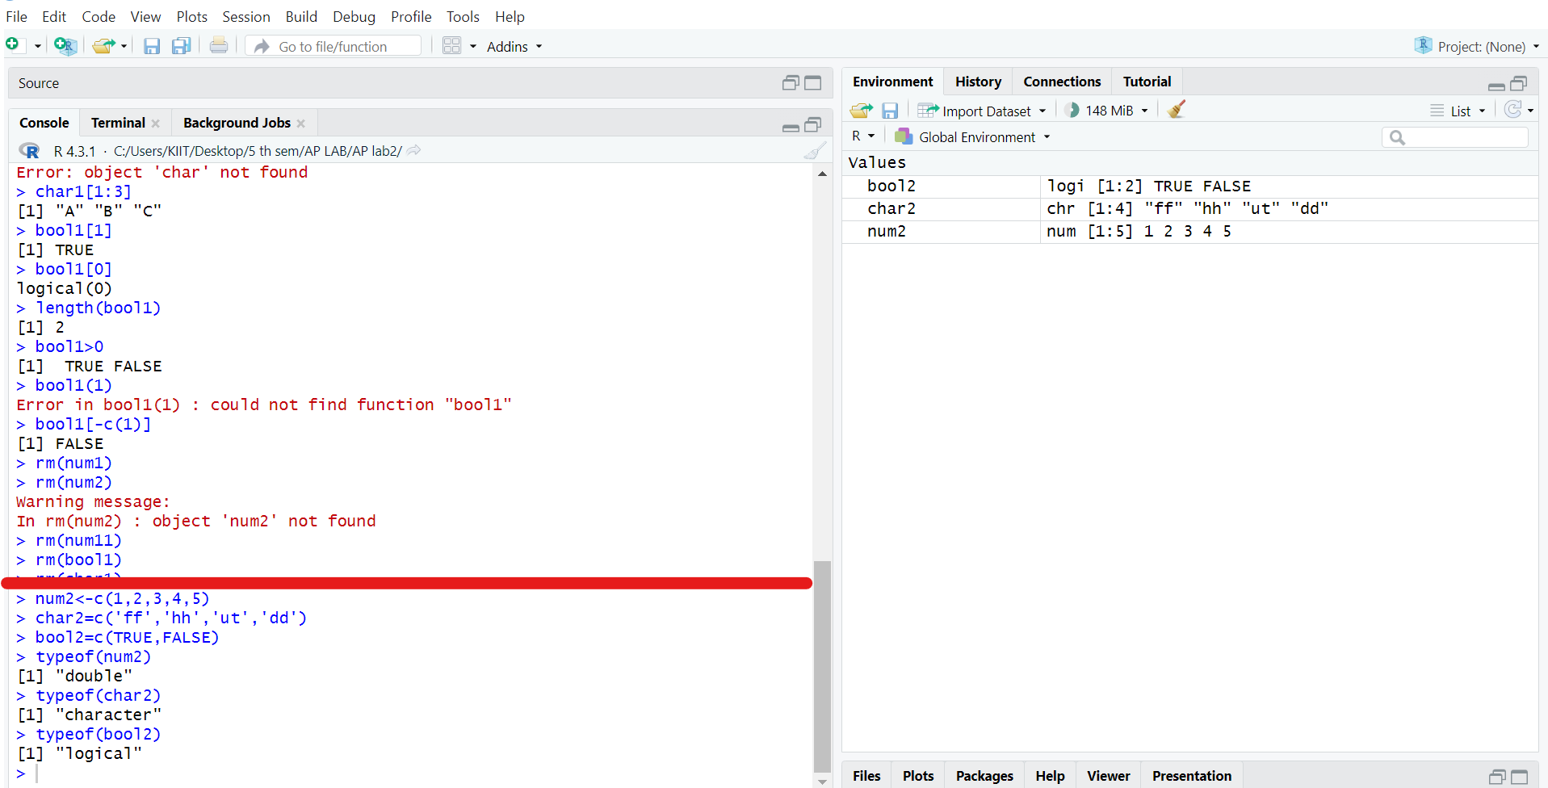

- WAP in R to initialize 5 elements in vector then display the vector
elements also find out the position of specific element. Also check whether a
specific is available within this vector or not.

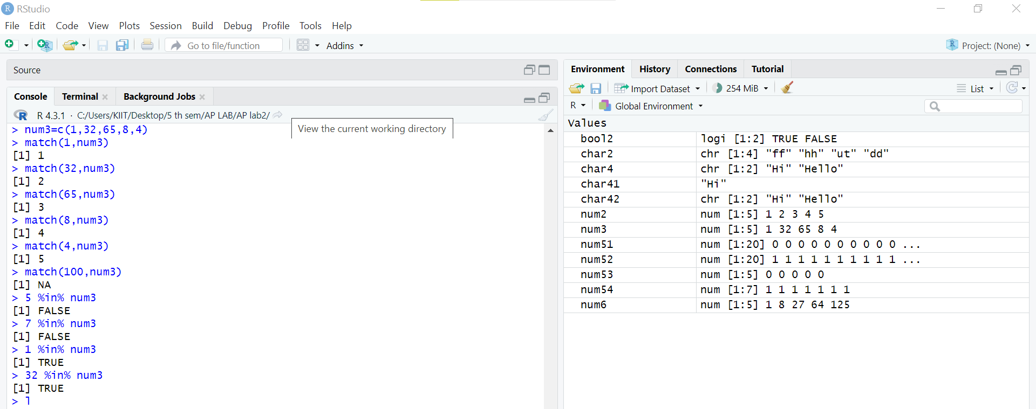

- WAP in R to initialize 2 vectors and then check both vectors are equal or
not.

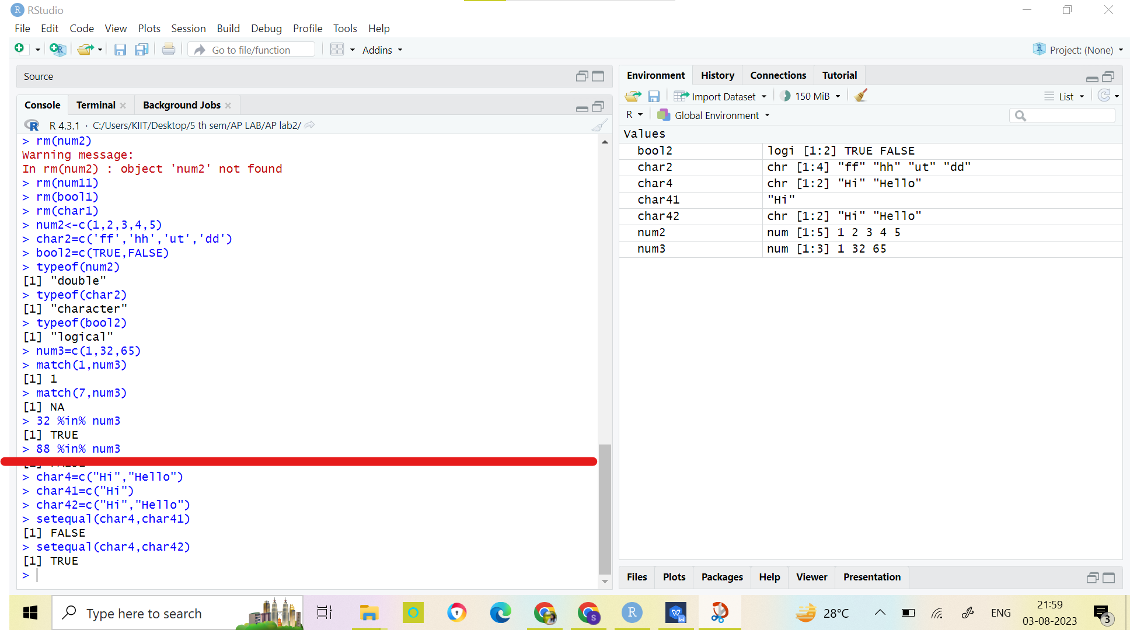

- WAP in r to initialize 2 vectors with 1s and 0s now perform add operation with 2 vectors.

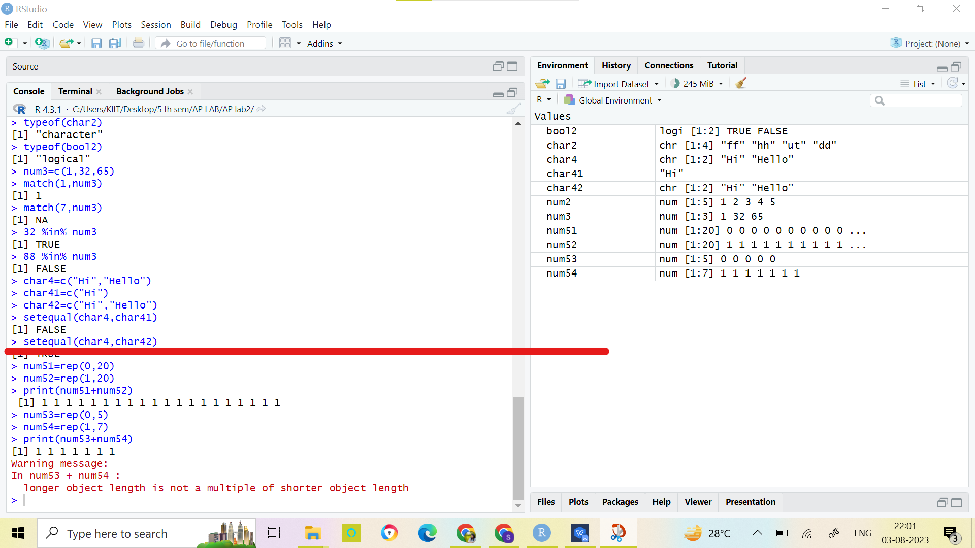

- WAP in r to initialize a vector with integers then evaluate this vector which is raise to the power of 3.

